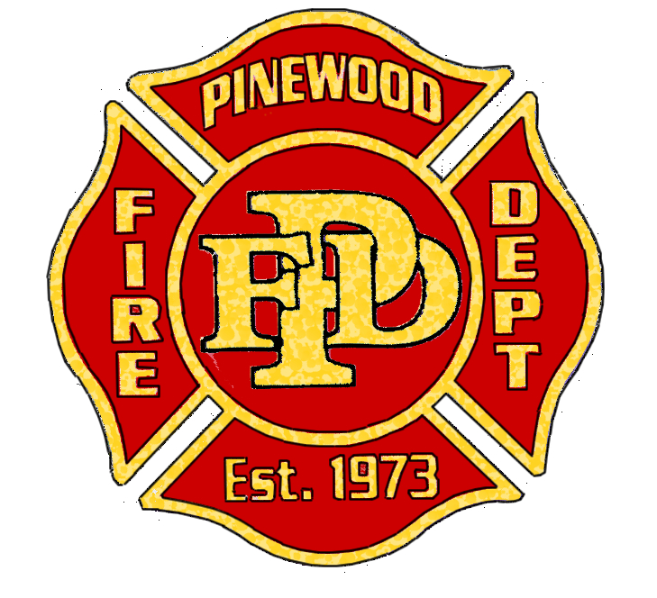

Special Board Meeting and Executive Session of the Pinewood Fire District Board of Directors
Tuesday, September 12, 2017
9:00 am at the Pinewood Sanitary District 18075 Navajo Rd., Munds Park, AZ 86017

NOTICE OF MEETING AND EXECUTIVE SESSION OF THE PINEWOOD FIRE DISTRICT BOARD OF DIRECTORS

Pursuant to A.R.S. § 38-431.02, notice is hereby given to the members of the Pinewood Fire District Board of Directors, and to the general public that the Pinewood Fire District Board will hold a meeting open to the public. The Pinewood Fire Districts Board of Directors may vote to go into executive session, which is not open to the public, for any item on the agenda pursuant to A.R.S. 38-431.03 (A).

1. CALL TO ORDER & PLEDGE OF ALLEGIANCE

2. ROLL CALL OF DISTRICT BOARD

3. EXECUTIVE SESSION: Interview of candidate(s) for Fire Chief position

4. EXECUTIVE SESSION: Discussion of candidate(s) responses

5. CALL TO THE PUBLIC: Open call to the public for non-agenda items. No action will be taken on any subject not on the agenda. Limit of five (5) minutes each will be enforced.

Next Meeting: September 19, 2017 at 3 P.M.

Date Approved: ___________________________________

By ______________________________________________ Date Posted:_______________________________
Barbara Timberman, Clerk of the Board

