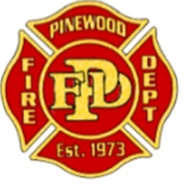
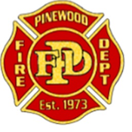
Pinewood Fire District
Eligibility List Announcement for
FULL-TIME Firefighter

Position: Firefighter/EMT or Firefighter/Paramedic
Schedule: 48/96 Shift rotation
Salary: $45,760 annual (plus proficiency pay $7,000 for CEP)
Benefits: Vacation & sick leave, educational assistance, 100% paid family medical insurance, dental and life insurance, uniform allowance, PSPRS retirement

The Pinewood Fire District is establishing an eligibility list for the position of Full-Time Firefighter/EMT
(or FF/CEP) with anticipated hiring opportunity).

Minimum Qualifications:
- 18 years of age
- High school diploma or equivalent (Fire Science Degree or Certificate preferred)
- Must possess an Arizona State Firefighter I&II cert
- Must have completed a CPAT within the last 12 months.
- State of Arizona EMT-B or EMT-P certification (Must be Arizona certified)
- Must pass pre-employment drug screen and background investigation
- Must successfully complete job-related physical and medical evaluation
- Must possess a valid Arizona driver’s license and have a satisfactory driving record, including insurability by the district’s insurance carrier.
- Must be able to read, write, and communicate in the English language
- Must be able to interact and work with paid and volunteer staff, and the general public

Application availability:
Online: https://pinewoodfire.org/wp-content/uploads/2019/09/Pinewood-Application-9-2019-update.docx
Email: soberly@pinewoodfire.org
Station 41: 475 E Pinewood Blvd, Munds Park AZ 86017 (Monday-Friday, between 8am and 5pm)

Application Deadline: September 30th, 2019 by 5 pm

Selection Process:
- Applications will be screened to determine applicants’ qualifications
- Candidates will be evaluated for skills, abilities and qualifications for this position, including written, practical, and oral board.
- Qualified candidates will be invited to attend the testing process to be scheduled at a later date.

Offer of Employment:
All offers of employment are conditional, subject to satisfactory results of pre-employment screening. Screening may consist of any or all of the following; reference checks, drug testing, pre-employment physical, and production of documents sufficient to demonstrate proof of certification.

Hiring List:
From this process, the department will create a hiring list to draw from to fill anticipated open firefighter position. The list will be effective for a year with the District’s option to revise it as we see the need.

Pinewood Fire District is an Equal Opportunity Employer and encourages all qualified individuals to apply.

